**Duplicate File Finder**

**A user-friendly desktop application to find and delete duplicate files from any selected folder and send a report via email.**

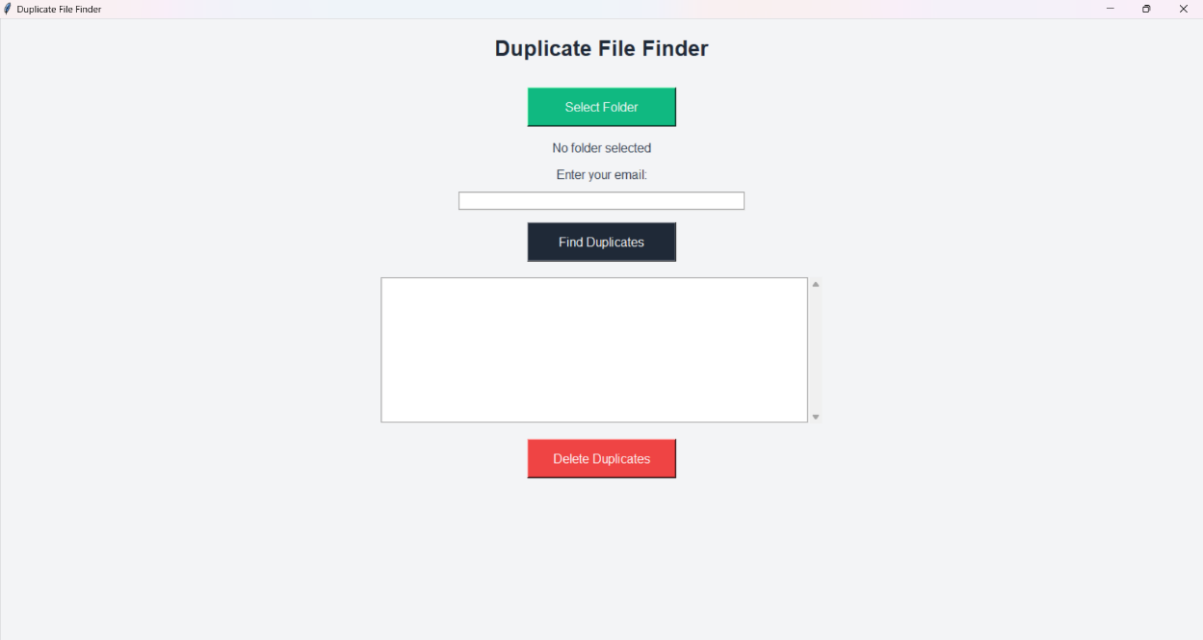

**Features**

* **Folder Selection**: Easily browse and select a folder to scan for duplicate files.
* **Duplicate Detection**: Uses MD5 hash algorithm to detect duplicate files with precision.
* **Email Log**: Automatically sends an email containing a log of all duplicate files detected.
* **File Deletion**: Safely delete duplicate files from your folder with a confirmation dialog.
* **Log Generation**: Generates a detailed log file for each execution with a timestamp.

**Tech Stack**

* **Language**: Python
* **Libraries**:
  + tkinter for building the graphical user interface.
  + hashlib for file hashing (MD5).
  + smtplib for sending emails.
  + pathlib, os for file handling.
  + ScrolledText for handling large text areas.

**Screenshots**

**Main Application Interface**

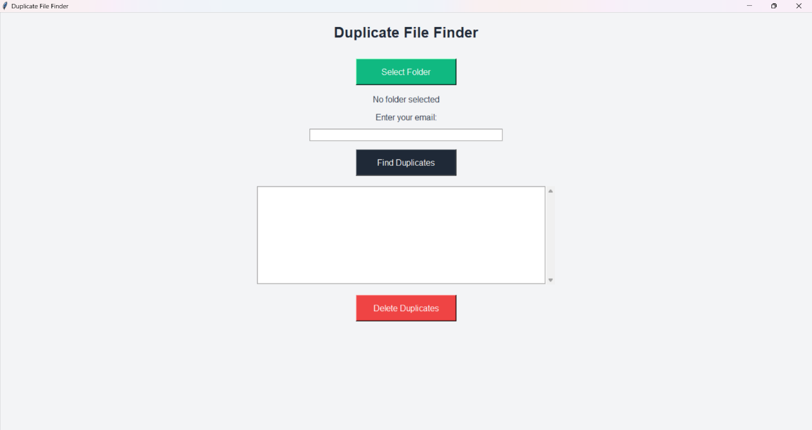

**Folder Selection**

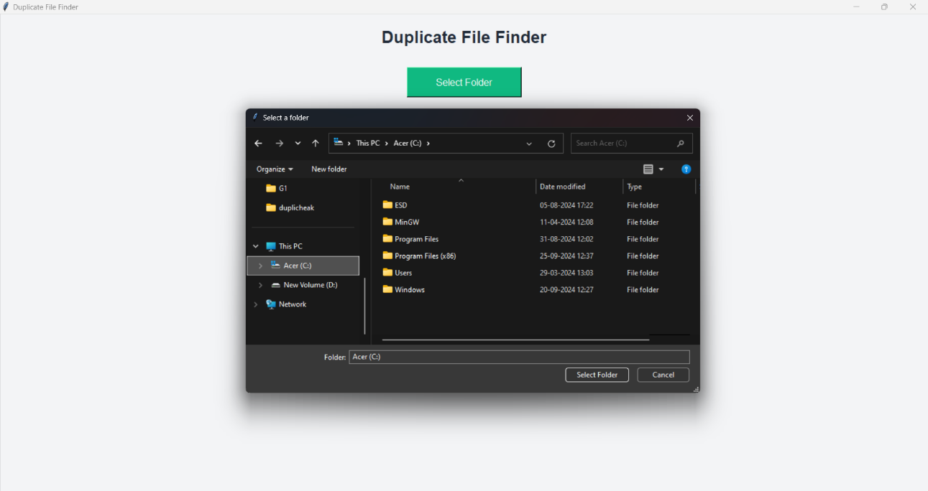

**Duplicate Files Display**

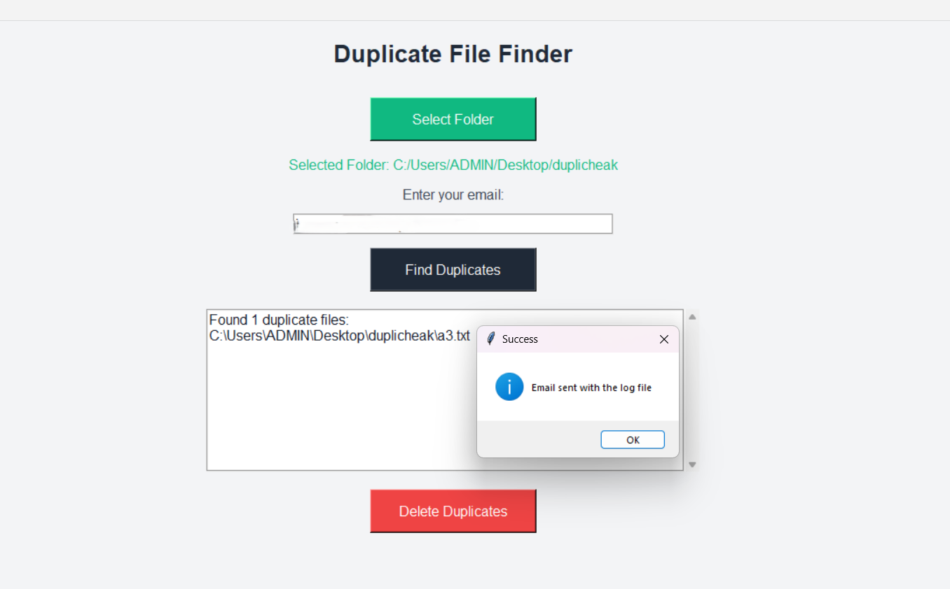

**How to Install**

1. Clone the repository or download the project files:

git clone https://github.com/username/duplicate-file-finder.git

1. Install the required Python libraries:

pip install -r requirements.txt

1. Ensure you have a valid **Gmail account** to use for sending the email log. Update the sender email and app password in the script.

**Usage**

1. **Run the application**:

python duplicate_file_finder.py

1. **Select a folder**: Click the "Select Folder" button and choose a directory to scan for duplicate files.

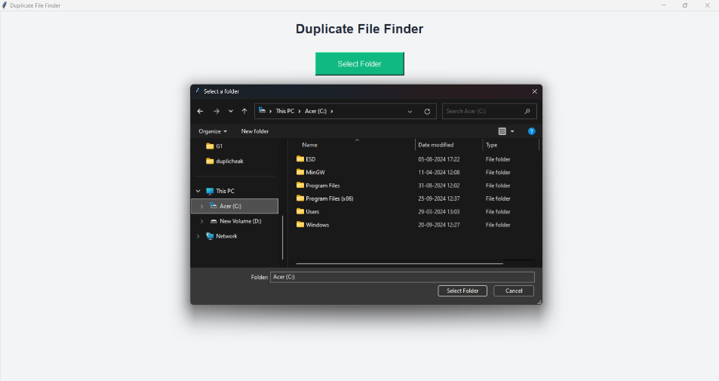

1. **Find Duplicates**: Click "Find Duplicates" to start scanning the selected folder. A log will display the duplicate files found.

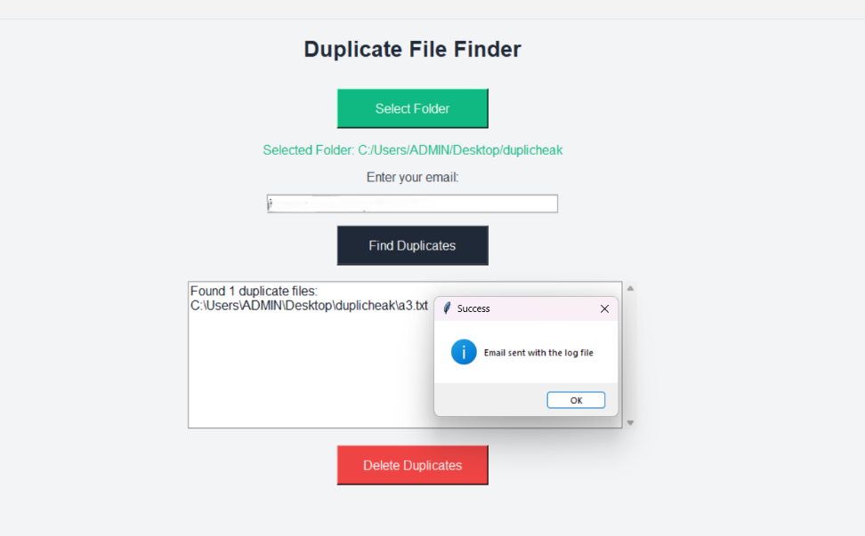

1. **Email Log**: If you've entered an email, a log file with duplicates will be sent to your inbox.

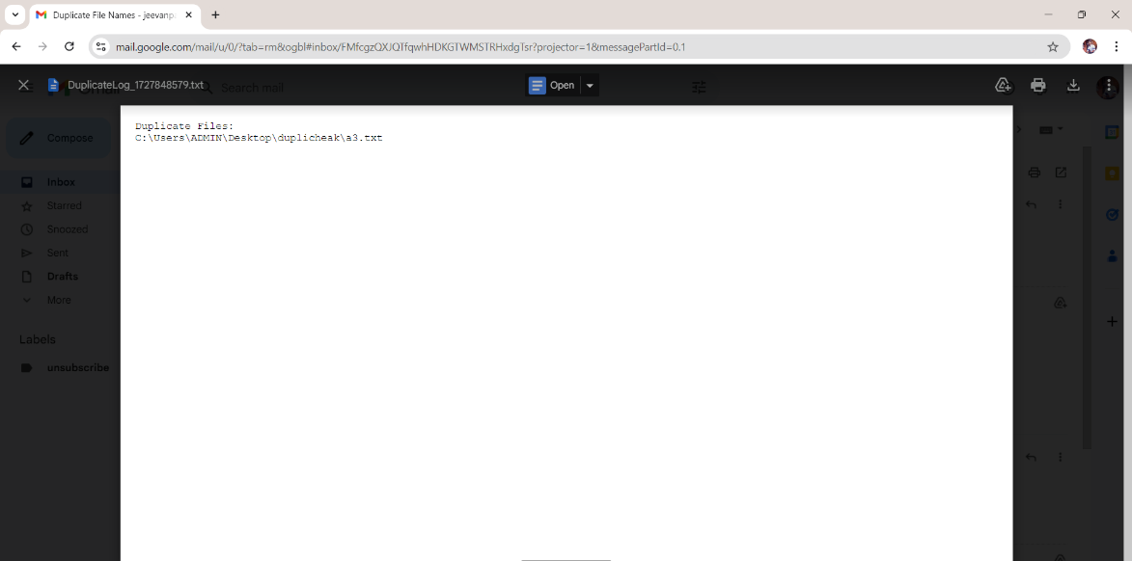

1. **Delete Duplicates**: Click "Delete Duplicates" to remove the files from your system. A confirmation will be asked before deletion.

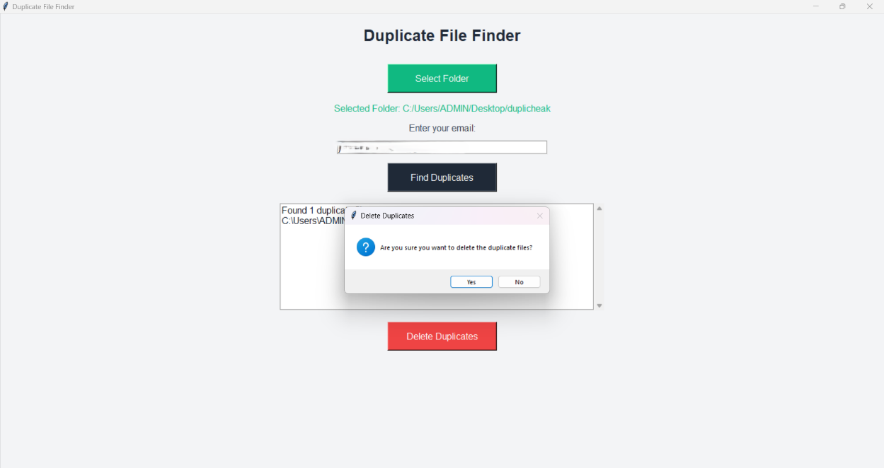

**Log Files**

The program generates a log file after every scan and places it in the Logs directory with a timestamp. This log contains all duplicate file paths.

Example of a log file name:

```

Log_1633024802.txt

```

**Email Configuration**

You need to configure your Gmail account to allow access via third-party apps (this is necessary for the smtplib library to send the email):

* Set your Gmail account to allow less secure apps or generate an **App Password** if using 2FA.

In the script, update the following lines with your email and app password:

fromaddr = "youremail@gmail.com"

s.login(fromaddr, "your-app-password")

**Contribution**

1. Fork the repository.
2. Create a new branch:

git checkout -b feature-branch

1. Commit your changes:

git commit -m "Add some feature"

1. Push to the branch:

git push origin feature-branch

1. Create a pull request.